Building a Custom VPC in Google Cloud Using Console and gcloud CLI: A Practical Guide for Cloud & DevOps Engineers

Introduction
Networking is the foundation of any cloud architecture. Before deploying workloads, securing applications, or designing scalable systems, building a properly structured Virtual Private Cloud (VPC) is essential.
In Google Cloud Platform, VPC is a global resource that allows you to create logically isolated networks for running cloud resources securely and efficiently.
This guide walks through creating a custom-mode VPC, configuring subnets, firewall rules, and deploying a VM instance inside the network — using both the Console and CLI approach.

Why VPC Architecture Matters
A well-designed VPC:
- Provides network isolation
- Controls inbound/outbound traffic
- Enables secure multi-tier architectures
- Supports hybrid connectivity (VPN / Interconnect)
- Forms the base for Zero Trust design
Unlike Amazon Web Services, where VPC is regional, GCP VPC is globally scoped, allowing seamless cross-region internal communication without additional peering.
This architectural difference is critical for scalable system design.

Architecture Overview
We will build:
- Custom Mode VPC
- One regional subnet
- Ingress firewall rule (SSH)
- VM instance inside the subnet
Logical Flow:
VPC (Global)
└── Subnet (asia-south1)
└── VM Instance
Step 1: Create a Custom VPC (Console Method)
Navigate:
VPC Network → VPC Networks → Create VPC Network
Press enter or click to view image in full size
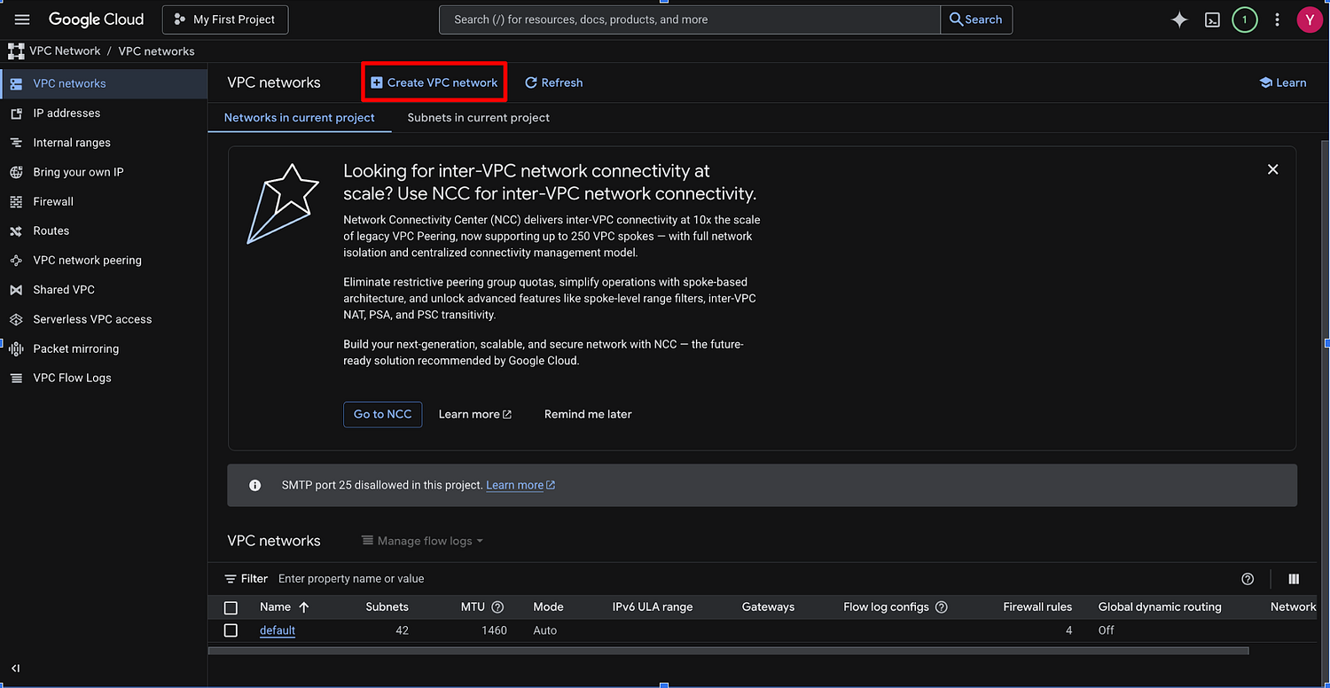

Configuration:
- Name: custom-vpc
- Subnet Creation Mode: Custom
- Subnet Name: pubic-subnet
- Region: asia-south2(delhi)
- IP Range: 10.0.0.0/24
Why Custom Mode?
Custom mode gives:
- Full CIDR control
- Controlled subnet planning
- Production-ready architecture design
Auto mode is generally avoided in enterprise setups.
Press enter or click to view image in full size
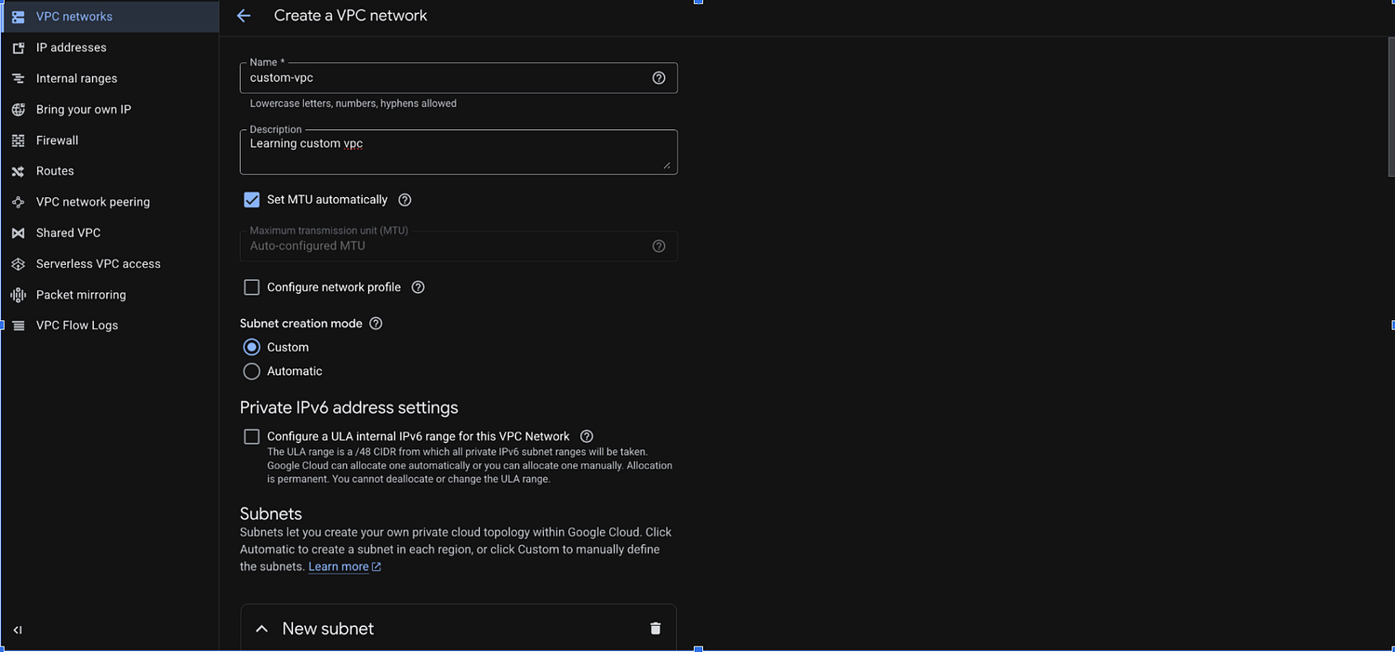
Press enter or click to view image in full size
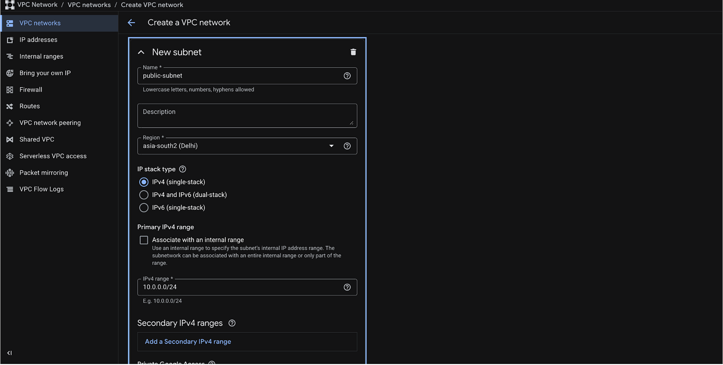

Step 2: Configure Firewall Rules
By default, GCP blocks all inbound traffic.
Create an SSH firewall rule:
- Direction: Ingress
- Targets: Specified target tags
- Source IP: 0.0.0.0/0
- Protocols: TCP:22
And then create vpc
⚠️ Security Best Practice:
In production, restrict SSH to a specific IP range instead of 0.0.0.0/0.
Press enter or click to view image in full size
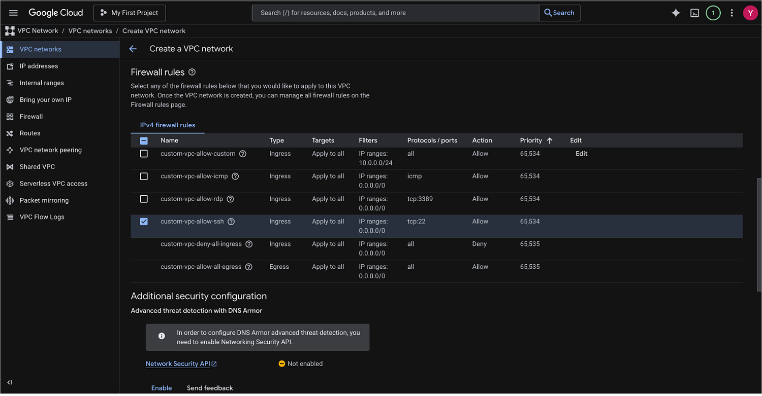
Press enter or click to view image in full size
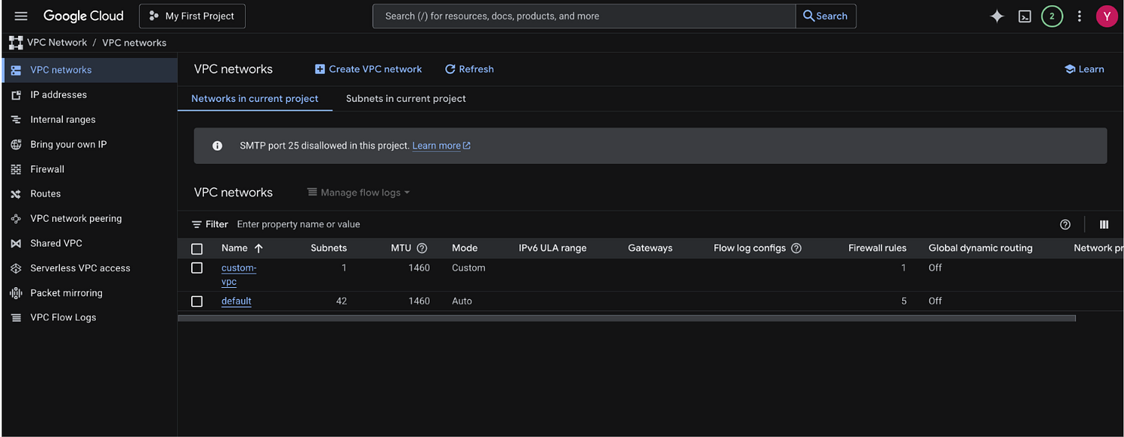

Step 3: Create a VM Instance Inside the VPC
Navigate to:
Compute Engine → VM Instances → Create Instance
Press enter or click to view image in full size
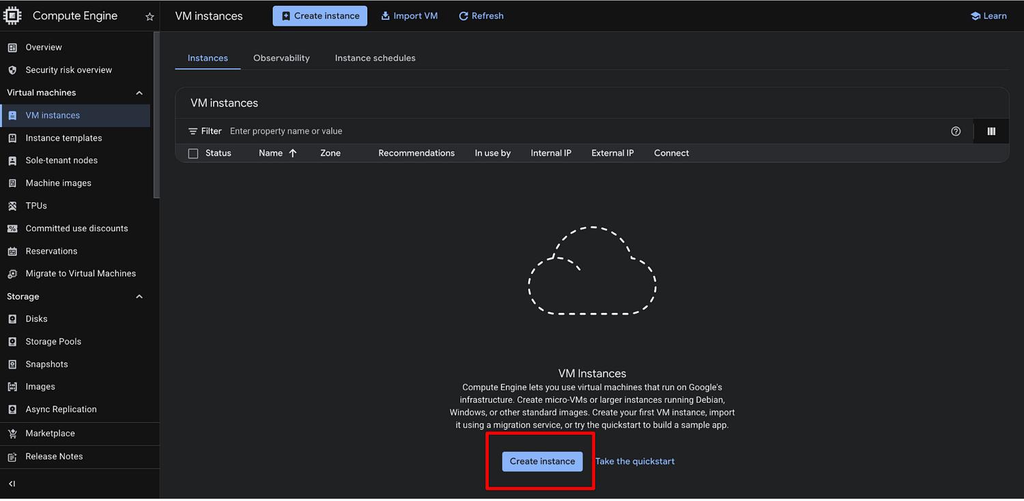
Press enter or click to view image in full size
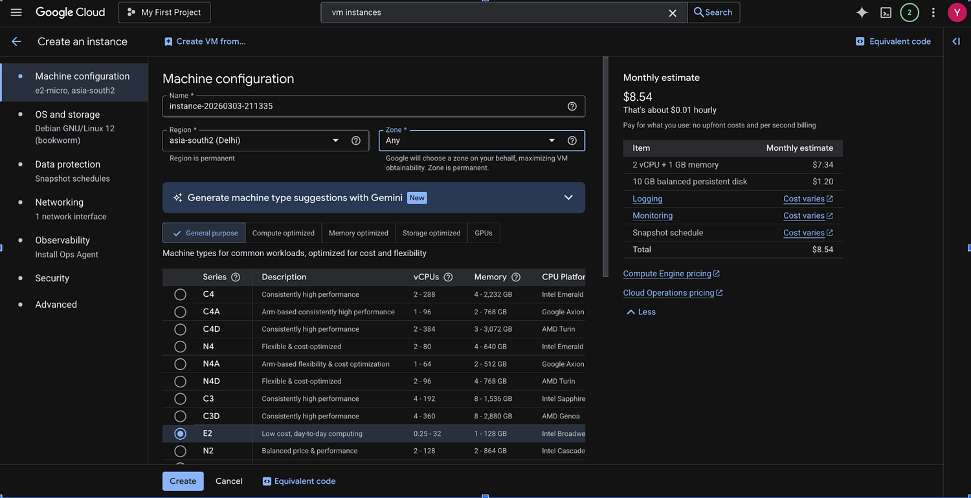
Go to Networking and add your created vpc
Press enter or click to view image in full size
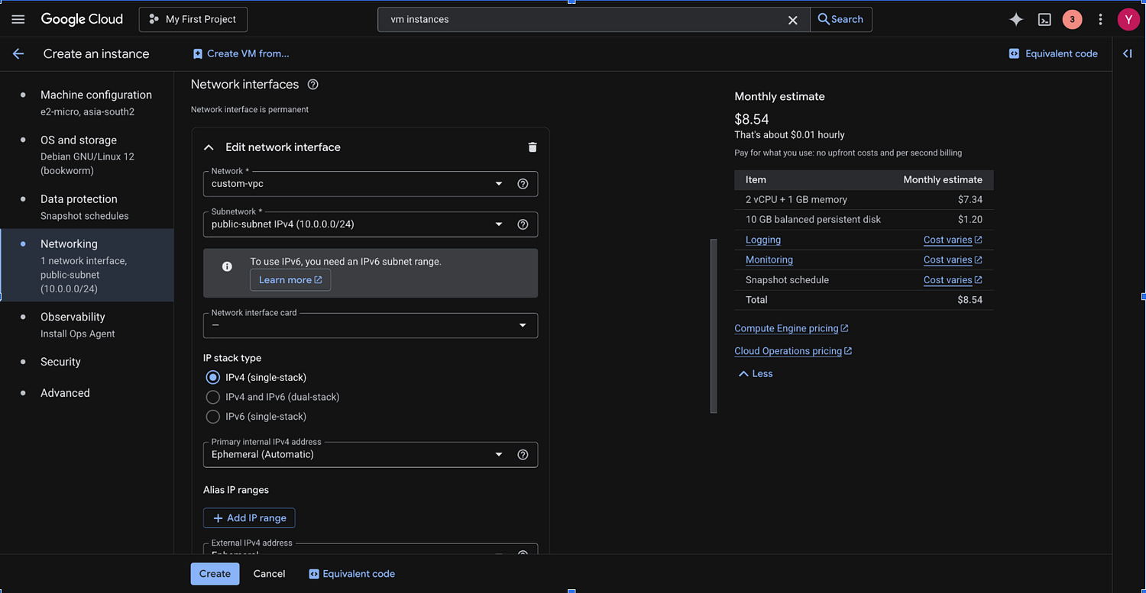
Security → manage access → add your ssh key.
Press enter or click to view image in full size
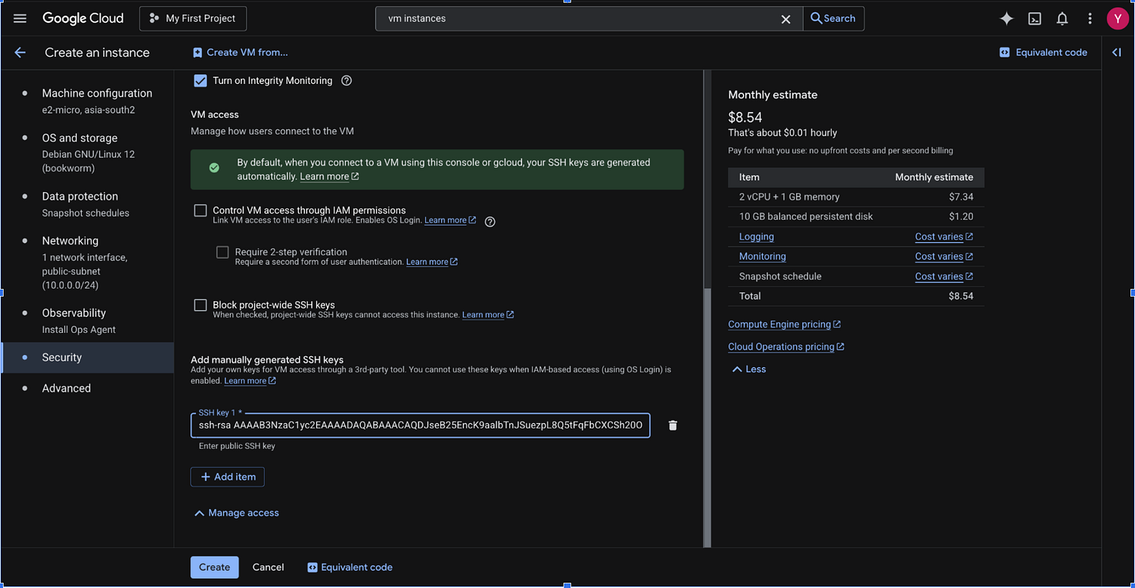
Press enter or click to view image in full size
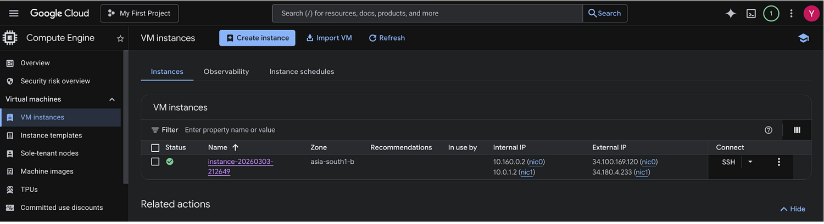
After deployment:
- Verify internal IP assignment
- Test SSH connectivity
- Validate outbound internet access
Press enter or click to view image in full size
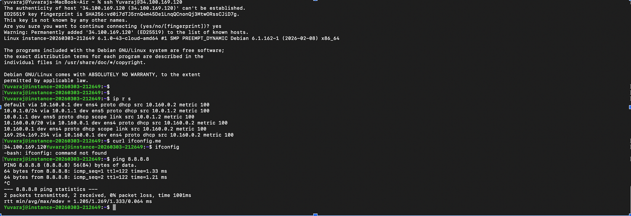

CLI Approach (Professional Practice)
Infrastructure engineers should prefer CLI or IaC.

Create VPC
gcloud compute networks create prod-custom-vpc \
— subnet-mode=custom

Create Subnet
gcloud compute networks subnets create prod-asia-subnet \
— network=prod-custom-vpc \
— region=asia-south1 \
— range=10.0.0.0/24

Create Firewall Rule
gcloud compute firewall-rules create allow-ssh \
— network=prod-custom-vpc \
— allow=tcp:22 \
— source-ranges=0.0.0.0/0

Cloud Shell Outputs:
yuvarajscyr@cloudshell:~ (project-ae681652-f49e-401a-9b3)$ gcloud compute networks create learn-custom-vpc — subnet-mode=custom
Created [https://www.googleapis.com/compute/v1/projects/project-ae681652-f49e-401a-9b3/global/networks/learn-custom-vpc].
NAME: learn-custom-vpc
SUBNET_MODE: CUSTOM
BGP_ROUTING_MODE: REGIONAL
IPV4_RANGE:
GATEWAY_IPV4:
INTERNAL_IPV6_RANGE:
Instances on this network will not be reachable until firewall rules
are created. As an example, you can allow all internal traffic between
instances as well as SSH, RDP, and ICMP by running:
$ gcloud compute firewall-rules create <FIREWALL_NAME> — network learn-custom-vpc — allow tcp,udp,icmp — source-ranges <IP_RANGE>
$ gcloud compute firewall-rules create <FIREWALL_NAME> — network learn-custom-vpc — allow tcp:22,tcp:3389,icmp
yuvarajscyr@cloudshell:~ (project-ae681652-f49e-401a-9b3)$ gcloud compute networks subnets create vpc-asia-subnet \
— network=learn-custom-vpc \
— region=asia-south1 \
— range=10.0.0.0/24
Created [https://www.googleapis.com/compute/v1/projects/project-ae681652-f49e-401a-9b3/regions/asia-south1/subnetworks/vpc-asia-subnet].
NAME: vpc-asia-subnet
REGION: asia-south1
NETWORK: learn-custom-vpc
RANGE: 10.0.0.0/24
STACK_TYPE: IPV4_ONLY
IPV6_ACCESS_TYPE:
INTERNAL_IPV6_PREFIX:
EXTERNAL_IPV6_PREFIX:
yuvarajscyr@cloudshell:~ (project-ae681652-f49e-401a-9b3)$ gcloud compute firewall-rules create allow-ssh \
— network=learn-custom-vpc \
— allow=tcp:22 \
— source-ranges=0.0.0.0/0
Creating firewall…working..Created [https://www.googleapis.com/compute/v1/projects/project-ae681652-f49e-401a-9b3/global/firewalls/allow-ssh].
Creating firewall…done.
NAME: allow-ssh
NETWORK: learn-custom-vpc
DIRECTION: INGRESS
PRIORITY: 1000
ALLOW: tcp:22
DENY:
DISABLED: False
yuvarajscyr@cloudshell:~ (project-ae681652-f49e-401a-9b3)$

Key Design Considerations

1️⃣ CIDR Planning
Avoid overlapping ranges if:
- Planning VPC Peering
- Hybrid VPN connection
- Multi-project networking

2️⃣ Least Privilege Networking
- Restrict ingress traffic
- Use service accounts properly
- Apply network tags

3️⃣ Global VPC Advantage
Because GCP VPC is global:
- Subnets are regional
- No need for cross-region peering
- Internal load balancing becomes simpler

Conclusion
Designing a secure and scalable VPC is the first step in cloud infrastructure engineering.
By creating a custom VPC, defining controlled subnets, and applying structured firewall rules in Google Cloud Platform, we build a production-aligned networking foundation.
For cloud engineers, mastering VPC architecture is not optional — it is fundamental.

